User: OpenMindDJ
Linux Fedora Core 5

This is the debug from the terminal when trying to load Ardour2 from KDE 3.5
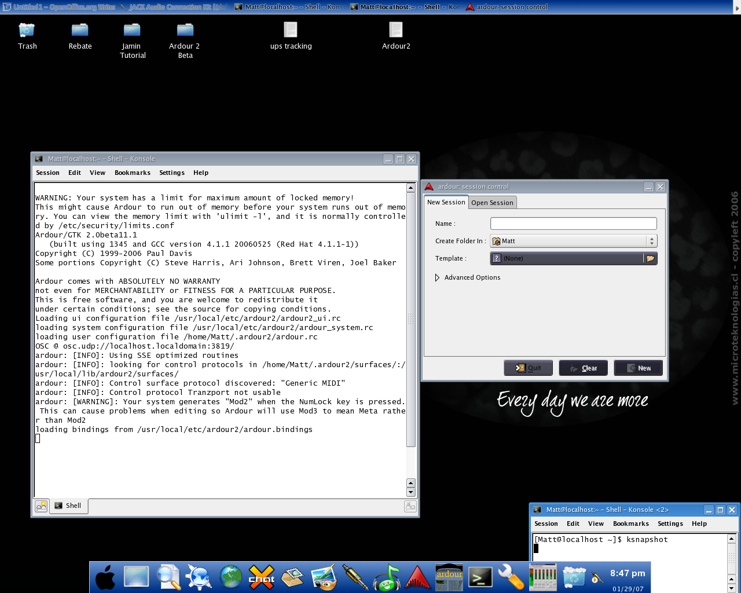
This is what it looks like when i try and Browse (I can't see the text)
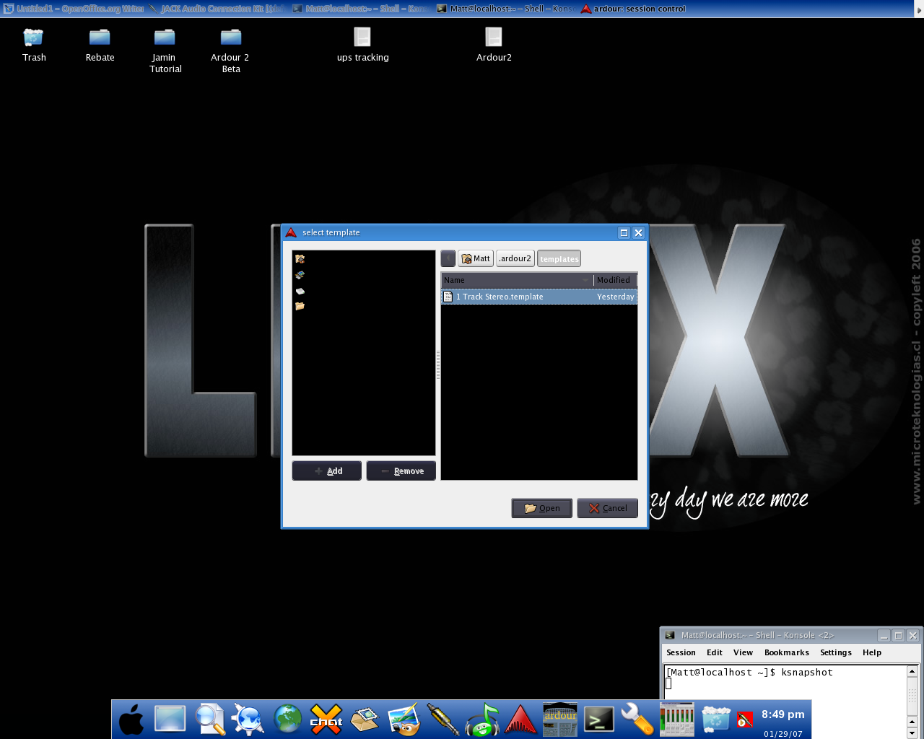

This is what Ardour2 looks like in KDE
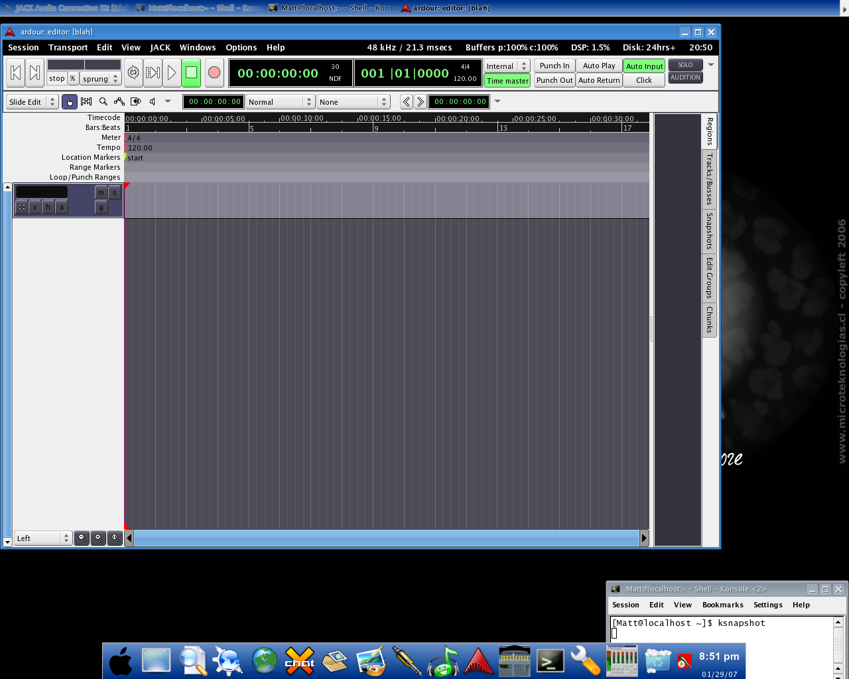

Loading Ardour2 from gnome
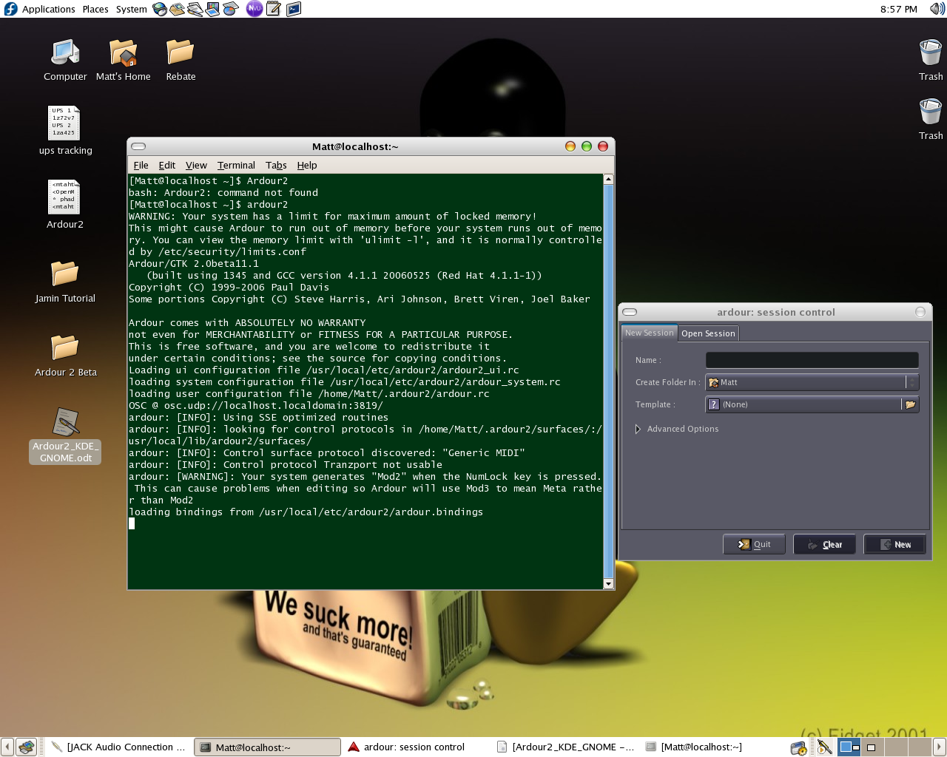
open a session and here is what Ardour2 looks like in Gnome


